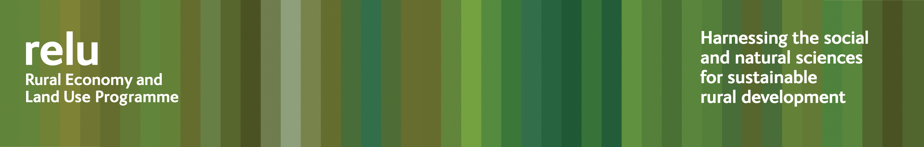

6 August 2009

INDEPENDENT REPORT CALLS FOR RETHINK ON FARM VETERINARY SERVICE

The veterinary profession needs to rethink its relationship with farmers and with the government, and play a more positive and central role in ensuring food safety, according to an independent report to the UK government, the veterinary profession and the farming industry.

“Unlocking potential, a report on veterinary expertise in food animal production”, is authored by Professor Philip Lowe, and draws on the deliberations of a working group that brought together Defra, the Scottish Government, the Welsh Assembly Government, the Royal College of Veterinary Surgeons, the British Veterinary Association and the Royal Veterinary College.

The report finds a widening gap between the perceptions of vets and farmers about the role of veterinary medicine. While many farm vets voice fears that farmers are increasingly unable to access vital services because of a tendency for newly-qualified practitioners to gravitate towards small animal practice, farmers are more inclined to regard vets as costly “quasi regulators” who add little value to their businesses.

Statistics do show a growing number of small animal practices, vastly overshadowing farm vet practices: just 10% of veterinary private practice is on farm animals. The report emphasises the urgent need to overcome the increasing marginalisation of this vital service.

Professor Lowe looks at ways in which the profession might halt the drift of its focus away from agriculture and food production, with better training and preparation for young vets on farm animal practice, and more use of technicians to carry out routine tasks as part of a multidisciplinary team, offering a more flexible and differentiated service.

He highlights weaknesses in the public health role of vets and comments on the cultural divide that has come about with the centralised development of the Meat Hygiene Service. This specialisation has cut the link between local vets and food hygiene in abattoirs, which is now largely implemented by professionals who have qualified abroad.

He finds, furthermore, that the roles, responsibilities and training of veterinarians in the welfare of farm animals are unclear, while the profession itself expresses dissatisfaction with some aspects of the government’s Veterinary Surveillance Strategy and the role of the vet in monitoring animals for exotic disease.

Professor Lowe said: “This report has been a major undertaking that could not have been achieved without the very active cooperation of the veterinary profession and of farmers, who have given generously of their time.

“All have shown a willingness to address the issues, and my conversations with the veterinary profession leave me in no doubt that they have the leadership and the energy to take on board the findings from my report and bring about a renewed sense, both within and beyond the animal health world, of the essential contribution made by food animal medicine.

“It is timely, for both farmers and vets to be looking to the future, and particularly at the role that vets need to play in ensuring the safety of the food chain. The new proposals from the government for responsibility and cost sharing on animal health present both challenges and opportunities. Vets have to be clear about where their expertise will fit into this picture.

“My recommendation is for the profession to seize the initiative and create a Veterinary Development Council, which could reconnect professional education and training with the needs of the primary customer, carve out new niches for technicians and develop the farm health planning role of vets. It would also provide an opportunity to formalise the major part that vets can play, helping to equip farmers with the skills in animal health that they need in order to run their businesses and to ensure the supply of safe and good quality food.”

Notes for editors:

- The report was published on Thursday 6 August 2009.
- Professor Philip Lowe is Duke of Northumberland Professor of Rural Economy, Centre for Rural Economy, Newcastle University and Director of the UK Research Councils’ Rural Economy and Land Use Programme (www.relu.ac.uk).
3 Contact Anne Liddon, Science Communications Manager, Rural Economy and Land Use Programme, tel 0191 222 6880 email anne.liddon@ncl.ac.uk to arrange interviews with Professor Lowe or with any other queries.

Ends

